**Process Definition Document**

|  |  |
| --- | --- |
|  |  |

Process Vendor Invoice

Date: 01-09-2025

**Process Design Document History**

|  |  |  |  |  |  |  |  |
| --- | --- | --- | --- | --- | --- | --- | --- |
| Date | Version | Role | Name | Organization | Function | Comments | |
| 01.09.2025 | **1.0** | **Author** | **Amr Ayman** | **Raya IT** | **BA** | | **Creation v1.0** |
|  |  |  |  |  |  | |  |

# Table of Contents

Process Definition Document 0

0

Table of Contents 2

I. Introduction 3

I.1 Purpose of the document 3

I.2 Objectives 3

I.3 Process key contact 4

II. As-Is process description 5

II.1 Process Overview 5

II.2 Standard of Metrics 5

II.3 Applications used in the process 6

II.4 Business Rules 6

II.5 As-Is Process map 7

II.6 Detailed As-Is Process Steps 9

II.7 Exceptions Handling 13

III. To-Be Process Description 13

III.3 In Scope of RPA 13

III.4 Out of Scope of RPA 13

IV. Other Observations 14

IV.1 Systems 14

IV.2 Reporting 14

# Introduction

## I.1 Purpose of the document

The Process Definition Document outlines the business process chosen for automation using UiPath Robotic Process Automation (RPA) technology.

The document describes the sequence of actions performed as part of the business process, the conditions and rules of the process prior to automation and how they are envisioned to work after automating it, partly or entirely. This specifications document serves as a base for developers, providing them with the details required for applying robotic process automation to the selected business process.

## I.2 Objectives

The Automation of the full process of Verify Account Positions Task in the ACME systems, reducing the Human interaction to zero, the system will operate seamlessly throughout the two systems of ACME system 1 delivering faster processing , reducing the duration time of time-consuming activities and improving departments’ overall performance and reliability.

|  |  |
| --- | --- |
| Objectives | Expected Benefits |
| Automate the full Process vendor invoice | **Eliminate manual intervention, ensuring end-to-end seamless execution.** |
| Reduce human interaction to zero | **Minimize errors from manual handling, improve compliance and accuracy** |
| Accelerate processing speed of verification tasks | **Shorten overall task cycle time, enabling faster turnaround for stakeholders** |
| Reduce duration of time-consuming activities | **Free up staff capacity for higher-value activities, leading to productivity gains** |
| Improve overall department performance | **Standardized processes, ensuring consistency and scalability** |
| Increasing system reliability through automation | **Lower risk of process failure, improve trust in system outputs** |
| Support continuous operations with minimal downtime | **Enhance operational efficiency and customer satisfaction** |

## I.3 Process key contact

|  |  |  |  |
| --- | --- | --- | --- |
| ****Role**** | ****Name**** | ****Contact details (email, phone number)**** | ****Notes**** |
| **Business Analyst** | **Amr Ayman - Raya IT** | **amr@gmail.com** |  |
| **SME** | **Eng. Mohamed Mesbah** | **M.Mesbah@gmail.com** | **Contact for questions, details, approvals** |

# As-Is process description

## II.1 Process Overview

The Process Vendor Invoice task is currently performed manually across ACME System 1, Staff must log in to System 1, extract Invoice pdf data, and go search for vendor in system first to check if vendor existed in system 1, If found, add the invoice details, else reject the operation and mail the staff manager.

The process involves repetitive steps such as Extracting pdf data and documenting missing data to add.

Due to the high level of manual intervention, the task is time-consuming, error-prone, and dependent on staff availability, often leading to delays in verification, inconsistent outputs, and operational inefficiencies. Additionally, manual handling increases the risk of overlooking discrepancies, requiring additional rework and cross-departmental follow-ups.

## II.2 Standard of Metrics

|  |  |  |
| --- | --- | --- |
| **#** | **Item** | **Description** |
| **1** | **Process full name** | **Process Vendor Invoice** |
| **2** | **Process Area** | **Finance** |
| **3** | **Department** | **Finance** |
| **4** | **Process short description (operation, activity, outcome)** | **Check for each work item WI3 , extract invoice pdf data, search for vendor in system 1 , if found add the invoice and complete item, else reject the process.** |
| **5** | **Process schedule and frequency** | **Daily, Monday to Friday, 9 am – 6 pm** |
| **6** | **# of items process / month** | **~4500** |
| **8** | **Process execution time** | **8.2 sec.** |
| **9** | **Peak period (s)** | **Q1 and Q2 Usually** |
| **10** | **Transaction Volume During Peak period** | **~6000** |
| **11** | **Total # of FTEs supporting this activity** | **5** |
| **13** | **Level of exception rate** | **8%** |
| **13** | **Input data** | **Invoice PDF** |
| **14** | **Output data** | **Added Invoice Data to system 1 or Mail** |
| **15** | **Return on Investment** | **Reduce the processing time by 80% and FTE to zero** |

## II.3 Applications used in the process­

|  |  |  |  |  |  |
| --- | --- | --- | --- | --- | --- |
| # | Application name & version | System Language | Thin/Thick Client | Environment/ Access method | Comments |
| **1** | **ACME System 1** | **English** | **Thick** | **Web Application** | **Majority of processing** |
| **2** | **Pdf Reader** | **English** | **Thin** | **Desktop App** | **Used only for extracting** |

## II.4 Business Rules

|  |  |
| --- | --- |
| Business Rule | Description |
| BR-01 | **Every PDF Must contain all data required like taxId, vendor Name , address, city , country** |
| BR-02 | **Each invoice must have w vendor existed in system 1** |
| BR-03 | **If the invoice total amount does not match the purchase order (PO) amount in the system , the invoice should be marked as exception and routed for manual review** |
| BR-04 | **The User Must have accessibility on modifying the account, either, request access** |
| BR-05 | **An invoice cannot be processed unless all mandatory fields (Invoice Number, Vendor Code, Invoice Date, Total Amount, PO Number) are present. If any field is missing, the work item must be marked as Business Exception.** |

## II.5 As-Is Process map

### High Level As-Is Process Map:

This chapter depicts the As-Is business process at a High Level to enable developers to have a high-level understanding of the current process.

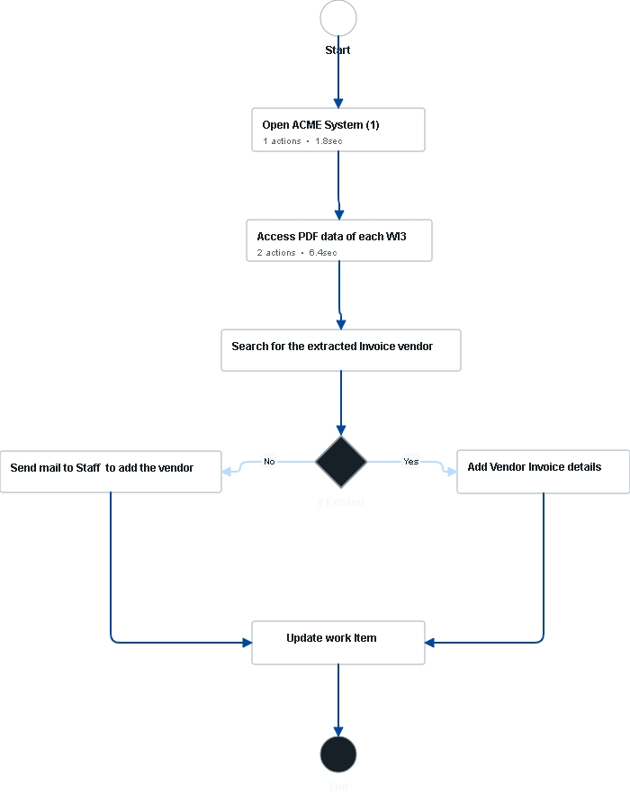

### Detailed As-Is Process Map:

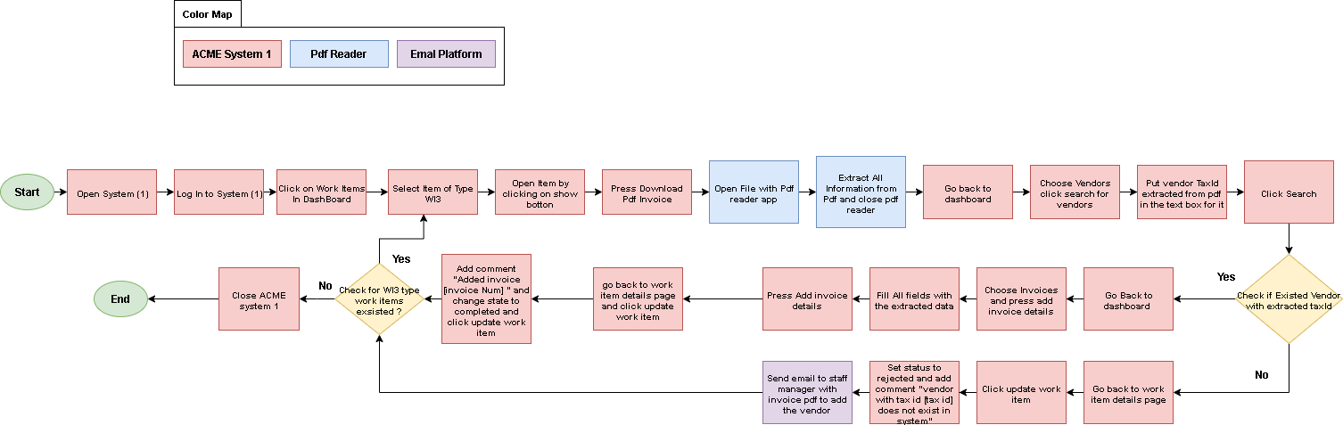

|  |  |  |  |  |  |
| --- | --- | --- | --- | --- | --- |
| Step | Short Description | | | | |
| 1.1 | Open ACME system 1 web application | | | | |
| 1.2 | Log into system 1with credentials | | | | |
| 1.3 | Click on Work items in menu to display all work items | | | | |
| 1.4 | **For Each Work** Item of type **WI3** perform the following steps | | | | |
| 1.4.A | Open Work item by clicking on the show button with icon (search) | | | | |
| 1.4.B | Press Download Pdf invoice | | | | |
| 1.4.C | Open file with pdf reader | | | | |
| 1.4.D | Extract all information from pdf and close pdf reader | | | | |
| 1.4.E | Go Back to dashboard | | | | |
| 1.4.F | Choose vendors , click search for vendors | | | | |
| 1.4.G | Put vendor Tax Id extracted from pdf in the text box for it | | | | |
| 1.4.H | Click search button | | | | |
| 1.4.I | Check If existed vendor with the extracted Tax Id ? | | | | |
| Yes | | | No | | |
| 1.4.I-Yes_1 | Go back to dashboard | | 1.4.I-No_1 | | Go back to work item details page |
| 1.4.I-Yes_2 | Choose invoices and press add invoice details | | 1.4.I-No_2 | | Click update work item |
| 1.4.I-Yes_3 | Fill all fields with extracted data | | 1.4.I-No_3 | | Set status to rejected and add comment “vendor with tax id does not exist in system” |
| 1.4.I-Yes_4 | Press add invoice details | | 1.4.I-No_4 | | Send email to staff manager with invoice pdf to add the vendor |
| 1.4.I-Yes_5 | Go back to work item details page and click update work item | |  | |  |
| 1.4.I-Yes_6 | Add comment “added invoice number and change state to completed then click update work item | |  | |  |
| 1.4.J | Check for WI3 type work items existed ? | | | | |
| Yes | | No | | | |
| 1.4.J-Yes_1 | **Continuing to iterate over WI3 items** | 1.4.**J**-No_1 | | Close ACME System | |

## II.6 Detailed As-Is Process Steps

|  |  |  |  |  |
| --- | --- | --- | --- | --- |
| Step | Step Action Description | Screen Shot | Expected Result | Possible Exception |
| 1.1 | **Open ACME system 1 web application** |  | **ACME website is opened** | A |
| 1.2 | **Log into system 1 with credentials** |  |  | B |
| 1.3 | **Click on Work items in menu to display all work items** |  |  | C |
| 1.4 | **For Each Work Item of type WI3 perform the following steps** |  |  |  |
| 1.4.A | **Open Work item by clicking on the show button with icon (search)** |  |  |  |
| 1.4.B | **Press download pdf invoice** |  |  |  |
| 1.4.C | **Open file with pdf reader app** |  |  |  |
| 1.4.D | **Extract All Information from pdf and close pdf reader** |  | **Pdf reader closed** | D |
| 1.4.E | **Go back to dashboard** |  |  |  |
| 1.4.F | **Choose vendors , click search for vendors** |  | **Search vendors tab opened** |  |
| 1.4.G | **Put vendor Tax Id extracted** |  |  |  |
| 1.4.H | **Click search** |  |  |  |
| 1.4.I | **Check if the vendor existed with extracted Tax Id** |  |  |  |
| 1.4.I-Yes_1 | **Go back to dashboard** |  |  |  |
| 1.4.I-Yes_2 | **Choose invoices and press add invoice details** |  |  |  |
| 1.4.I-Yes_3 | **Fill all fields with extracted details** |  |  |  |
| 1.4.I-Yes_4 | **Press add invoice details** |  | **All information submitted** |  |
| 1.4.I-Yes_5 | **Go back to work item details and click update work item** |  |  |  |
| 1.4.I-Yes_6 | **Add comment “added invoice number “ and change state to completed and press update work item** |  |  |  |
| 1.4.I-No_1 | **Go back to work item details page** |  |  |  |
| 1.4.I-No_2 | **Click on update work item button** |  |  |  |
| 1.4.I-No_3 | **Add comment “no vendor with tax ID existed “ and change state to rejected and press update work item** |  |  |  |
| 1.4.I-No_4 | **Send email to staff manager with invoice pdf to add the vendor** |  | **Email sent with pdf** |  |
| 1.4.J | **Check for WI3 work items if existed ?** |  |  |  |
| 1.4.J-Yes_1 | **Continue to iterate through tasks** |  |  |  |
| 1.4.J-No_1 | **Close acme system** |  |  |  |

## II.7 Exceptions Handling

|  |  |  |
| --- | --- | --- |
| # | Exception | Expected Action |
| A | **Something went wrong when open application** | **Wait 30 seconds then try and repeat 3 times , if not escalate to staff manager** |
| B | **Error When signing in** | **Try 3 times maximum if not working , report to staff manager** |
| C | **Showing Nothing when processing list of items** | **Refresh and Try again 1 time , if not , escalate to staff manager** |
| D | **Missing Data in Pdf** | **Send mail to staff manager , and reject process** |

# To-Be Process Description

## III.3 In Scope of RPA

The activities in of the scope of RPA:

Full scope of the process for RPA – to be 100% automated

## III.4 Out of Scope of RPA

There are no activities out of scope for RPA.

* For complex reporting requirements, include them into a separate document and attach it to the present documentation

# Other Observations

## IV.1 Systems

|  |  |  |
| --- | --- | --- |
| System | Usage | Frequency |
| ACME system1 web application | **Primary use for process** | **Once / case** |
| Pdf reader | **Used to open pdf file and extract information** | **Once / case** |

## IV.2 Reporting

|  |  |  |
| --- | --- | --- |
| Report Name | Source | Purpose |
| Email with invoice rejected | **Automated System** | **To Inform the staff manager with the rejected case to add vendor** |